Water Quality Summary

LaPlatte River, 2017

South Chittenden River Watch

- The South Chittenden River Watch (SCRW) is a volunteer group that has been monitoring water quality in four watersheds in southern Chittenden County since 2004.
- Long term trends are tracked at a sub-watershed scale using over 30 monitoring sites (about 15 monitored per year). We monitor from the LaPlatte intersection with Falls Road (LP03) to the Waste Water Treatment Facility in Hinesburg (LP09)
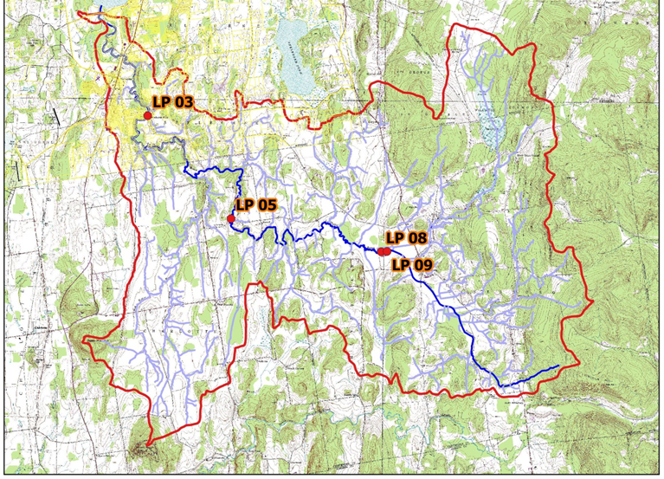
- Results are used to understand baseline water quality conditions, determine effectiveness of "Best Management Practices", and identify hot spot phosphorus loading and critical source area locations in need of remediation recommendations and investments.
- LCA, towns, and citizens rely on SCRW monitoring data results to understand stream water quality conditions under current regulations, inform education outreach efforts, town plan and regulations updates, regional plan updates, monitor effectiveness of storm water practices and sewer treatment systems and to inform optimal conservation practices designs for water quality improvement projects.
LaPlatte Sampling Stations – 2017
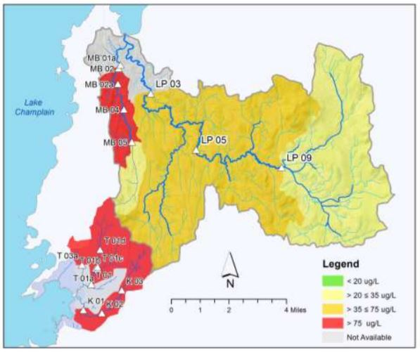
LaPlatte River Results
Phosphorus Loading - 2017
- The LaPlatte River from Falls Rd to Lagoon Rd is stressed due to sediment and phosphorus loading
- Nitrogen and chloride remain consistently below State standards since 2004
- Aquatic biota health has decreased from good to fair between 2009 and 2016
- Phosphorus consistently exceeds the state standard during low flow conditions
- The upper reaches of the LaPlatte in Hinesburg and select reaches in Charlotte have poor channel stability, making the river vulnerable to increased sediment and nutrient loading and poor conditions for aquatic organism habitat

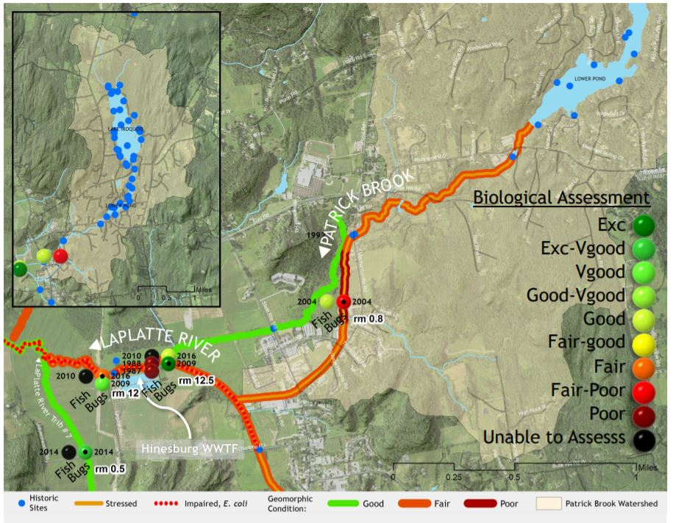

Tracking the Biological Health and Aquatic Habitat of the LaPlatte
Seventeen of Vermont’s waters are biologically impaired due to urban stormwater runoff; six of those are in Basin 5 (northern Lake Champlain drainage), including the LaPlatte. Patrick Brook flows into the village of Hinesburg and joins the LaPlatte. These waters fail to meet certain Vermont Water Quality Standards and are trending toward poor biological conditions based on biological monitoring data. Poor biological conditions due to stormwater impacts lead to stormwater impairment status (state/fed 303(d) list) and a required restoration plan that could cost millions of dollars to host towns. This is an indicator of where better land use planning should occur. Currently, the Munroe Brook in Shelburne is listed as stormwater impaired. Sections of the LaPlatte River also have poor biology conditions and are being studied by VT DEC, Lewis Creek Association and Lake Iroquois Association.

