**LaPlatte River Watershed**

Water Quality Summary 2016 (High Flow)

South Chittenden River Watch

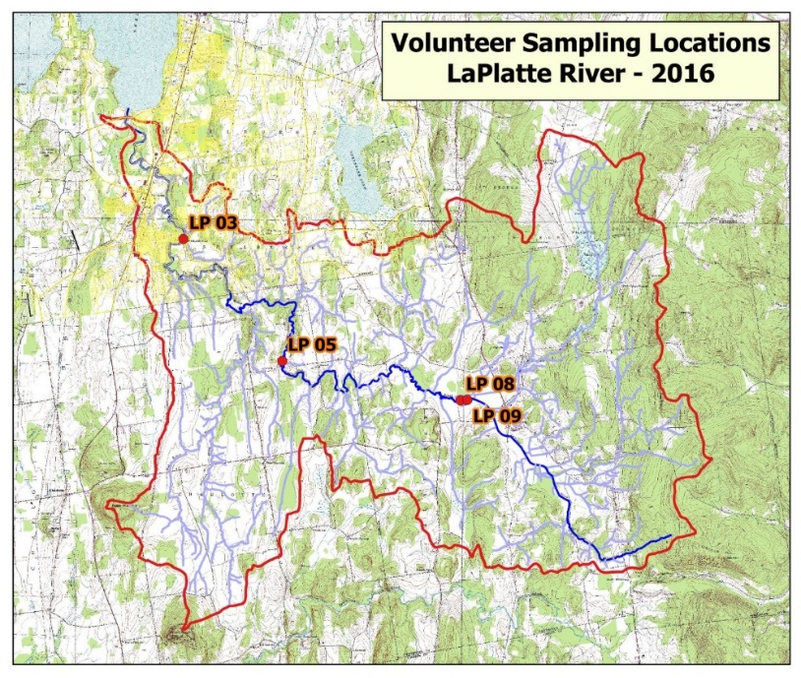SCRW has been monitoring water quality in the LaPlatte River since 2011. Segments of the LaPlatte River main stem and Mud Hollow Brook are listed as impaired for contact recreation uses due to impacts from agricultural runoff and streambank erosion (VTDEC, 2016a). Additionally, the LaPlatte River main stem downstream of Hinesburg and Patrick Brook from its Lower Pond to its confluence with the LaPlatte are each listed as stressed waters with impacts to aquatic health, aesthetics and secondary contact recreation uses resulting from development, channelization and agricultural land uses (VTDEC, 2016b). Monitoring is conducted to track conditions of the River with respect to Vermont Water Quality standards; and to estimate relative contributions of sediment and nutrients from each catchment to Lake Champlain in the context of the Lake Champlain Total Maximum Daily Load (TMDL) for phosphorus. Three different monitoring sites along the LaPlatte River define sub-watersheds in this catchment. In 2016, high-flow events were targeted to capture those times responsible for greatest loading to the lake. However, since calendar year 2016 was a below-normal precipitation year, and therefore flows in area rivers were below normal**,** it was a challenge to identify high-flow conditions for sampling. In the end, two moderate-flow events (August 18 and Nov 22) and one low-flow event (Nov 8) were captured.

|  |  |  |
| --- | --- | --- |
| **Station** | **Town** | **Road Intersection** |
| LP 03 | Shelburne | Falls Road |
| LP 05 | Charlotte | Carpenter Road |
| LP 09 | Hinesburg | Above Hinesburg WWT outfall |

**Suspended Sediment**

Sediment was monitored in each of the SCRW watersheds by analyzing for Total Suspended Solids (TSS). While Vermont Water Quality Standards are established for Turbidity, TSS has been monitored historically in SCRW watersheds to examine patterns in the relative phosphorus burden of sediments with fluctuating discharge, and to enable coarse estimates of sediment loading to receiving waters. Historically, Turbidity has been monitored alongside TSS to establish a relationship between Turbidity and TSS. In 2016, however, Turbidity/TSS analyses were limited to LaPlatte River stations.

TSS was analyzed during two events at all stations, and ranged from 1.75 to 40 mg/L. TSS was generally somewhat higher in concentration during the moderate flow event (August 18) than during the low-flow event (Nov 8).

Turbidity samples were collected at LaPlatte River stations on all three sample dates. The Vermont Water Quality Standard for Turbidity in warm-water Class B streams (25 NTUs) is applicable as an annual average under “low flow” dry weather base-flow conditions (VWMD, 2016). Only one sample date during 2016 met these conditions. On November 8, Turbidity did not exceed that standard at any of the three LaPlatte River stations.

**Phosphorus**

Particulate phosphorus was high on November 8th above the Hinesburg WWTF outfall, then dropped at Carpenter Road, mimicking that of solids. Dissolved phosphorus also decreased moving downstream. Particles likely settled out as they traveled downstream in these low-moderate flow conditions. During low flow conditions, TP ranged from17.4 to 47.2 µg/L.



The instream phosphorus standard of 27 µg/L for warm-water medium gradient (WWMG) wadeable stream ecotypes in Class B waters is applicable at low median monthly (LMM) flow conditions during June through October (VWMD, 2016). Only the November 8 sampling event was classified as a low flow, where daily mean flow measured at Shelburne Falls on the LaPlatte River (6.2 cfs) was nearly at the LMM (5 cfs) (Table A-1). TP concentrations on this date exceeded 27 µg/L at all sampling stations in SCRW watersheds.

**Nitrogen**

Total Nitrogen (TN) was analyzed during each event at all stations, and ranged from 0.2 to 2.6 mg/L. Given elevated nitrogen concentrations detected historically, all stations were also tested for nitrate and nitrite forms of nitrogen (N03-N02). Nitrate-nitrite concentrations ranged from <0.05 to 1.2 mg/L. TN and N03-N02 concentrations on these low-flow and moderate-flow sample dates were well below the water quality standard for Class B waters of 5.0 mg/L as nitrate-N (which applies at flows exceeding LMM; VTWMD, 2016).

N03-N02 forms of nitrogen were detected primarily in the Kimball Brook stations on moderate flow dates (Aug 18, Nov 22), and at the LaPlatte stations during the low-flow event (Nov 8).

**Conclusions and Recommendations**

Due to weather conditions that resulted in lower-than-normal stream flows, SCRW was unable to monitor high-flow conditions on the LaPlatte River in 2016.

* There is an upstream source of Particulate Phosphorus to look into, which could be related to agriculture, erosion, or developed lands runoff including roads.
* Unlike in 2015 when TP concentrations increased moving downstream, TP concentrations decreased moving downstream. This is likely due to lower flows, and should continue to be monitored.
* TN concentrations decreased from 2015, but followed a similar trend of increasing moving downstream. This trend should continue to be monitored in 2017.
* Solids followed a similar trend of increasing downstream, like 2015, but concentrations were consistently lower, potentially due to lower than average flows.
* Higher flows likely mobilized sediment particles into the stream that were dormant at low flows.

For more information, contact Krista Hoffsis at (513) 470-7554 or visit www.lewiscreek.org